Open Data Document API

# Authentication

The Open Data Document API endpoints require a JSON Web Token (JWT) issued from our login application. To receive a JWT, you will need a client id and the necessary scopes to access Open Data. To obtain the client credentials, submit a Footprints ticket, and the USAJOBs development team will provide a Client ID for your application.

Once you have your client credentials, you can then refer to the below link to get the necessary information to make the Open ID Connect call to receive your JWT.

<https://login.test.usajobs.gov/.well-known/openid-configuration>

The diagram below outlines the authentication and data retrieval process.

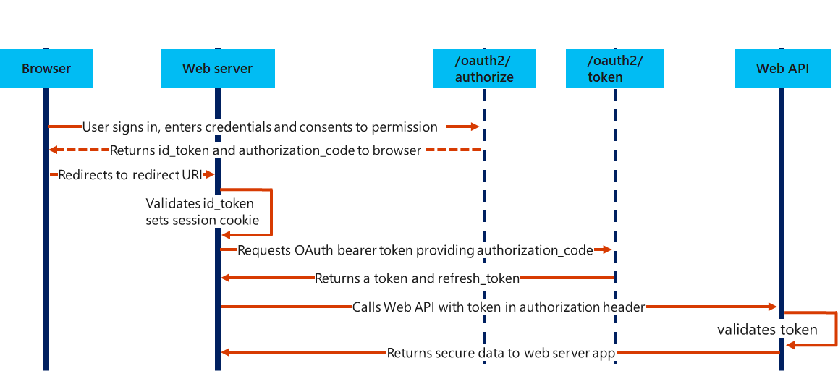

# API Reference

## Resource

GET /api/v1.0/profiles/my/documents

Retrieves a list of documents from the authenticated candidate’s profile that are available to be attached to an application.

#### Parameters

| Name | Description |
| --- | --- |
| category (query) | Only return documents of the specified category. This is an optional field. |

#### Response

JSON:

[

{

"documentID": "string",

"name": "string",

"previewUrl": "string",

"category": "Resume",

"format": "Word"

}

]

| Name | Type | Description |
| --- | --- | --- |
| documentID | String | Document identifier |
| name | String | User defined document file name |
| previewUrl | Date | URL used to retrieve the document file data |
| category | String | The document type (e.g., Resume, Transcripts, Other) |
| format | Date | The file format (e.g., Word, PDF) |

## Resource

GET /api/v1.0/applications/{applicationId}/documents

Retrieves a list of documents that are associated to an application.

#### Parameters

| Name | Description |
| --- | --- |
| applicationId (path) | The identifier of the application for which the document list is being retrieved. This is a required field. |

#### Response

JSON:

[

{

"documentID": "string",

"name": "string",

"previewUrl": "string",

"category": "Resume",

"format": "Word"

}

]

| Name | Type | Description |
| --- | --- | --- |
| documentID | String | Document identifier |
| name | String | User defined document file name |
| previewUrl | Date | URL used to retrieve the document file data |
| category | String | The document type (e.g., Resume, Transcripts, Other) |
| format | Date | The file format (e.g., Word, PDF) |

## Resource

POST /api/v1.0/applications/{applicationId}/documents

Replaces the list of documents associated with an application.

#### Parameters

| Name | Description |
| --- | --- |
| applicationId (path) | The identifier of the application for which the document list is being associated. This is a required field. |

#### Request Body

The request body contains an array of identifiers for each document that is to be associated with the application.

JSON:

[

"string"

]

#### Response

The response returns the list of documents associated with the application after the update is complete.

JSON:

[

{

"documentID": "string",

"name": "string",

"previewUrl": "string",

"category": "Resume",

"format": "Word"

}

]

| Name | Type | Description |
| --- | --- | --- |
| documentID | String | Document identifier |
| name | String | User defined document file name |
| previewUrl | Date | URL used to retrieve the document file data |
| category | String | The document type (e.g., Resume, Transcripts, Other) |
| format | Date | The file format (e.g., Word, PDF) |

## Resource

PUT /api/v1.0/applications/{applicationId}/documents/{documentId}

Adds a document to the list of documents for an application.

#### Parameters

| Name | Description |
| --- | --- |
| applicationId (path) | The identifier of the application for which the document is being added. This is a required field. |
| documentId (path) | The identifier of the document being added. This is a required field. |

#### Response

The response returns the document being added to the application.

JSON:

{

"documentID": "string",

"name": "string",

"previewUrl": "string",

"category": "Resume",

"format": "Word"

}

| Name | Type | Description |
| --- | --- | --- |
| documentID | String | Document identifier |
| name | String | User defined document file name |
| previewUrl | Date | URL used to retrieve the document file data |
| category | String | The document type (e.g., Resume, Transcripts, Other) |
| format | Date | The file format (e.g., Word, PDF) |

## Resource

DELETE /api/v1.0/applications/{applicationId}/documents/{documentId}

Removes a document from the list of documents for an application.

#### Parameters

| Name | Description |
| --- | --- |
| applicationId (path) | The identifier of the application for which the document is being added. This is a required field. |
| documentId (path) | The identifier of the document being removed. This is a required field. |

#### Response

The response returns the document being removed from the application.

JSON:

{

"documentID": "string",

"name": "string",

"previewUrl": "string",

"category": "Resume",

"format": "Word"

}

| Name | Type | Description |
| --- | --- | --- |
| documentID | String | Document identifier |
| name | String | User defined document file name |
| previewUrl | Date | URL used to retrieve the document file data |
| category | String | The document type (e.g., Resume, Transcripts, Other) |
| format | Date | The file format (e.g., Word, PDF) |