**USAJOBS**

**Streamlined Application Implementation Guide**

**October 2023**



 The contents of this document are confidential and shall not be disclosed outside the government and shall not be duplicated, used or disclosed-in whole or in part-for any purpose other than that intended by the creator.

**Table of Contents**

Purpose 2

Scope 2

Definitions 2

Benefits of the streamlined application flow 3

Design flows 4

What will remain the same in Streamline application flow: 4

What will change in Streamline application flow: 5

Development and test 6

How to implement 7

Timeline 7

Business success checklist 8

Contact List 8

Appendix 9

Rollback scenarios 9

# Purpose

This document is a guide for Talent Acquisition System providers for the streamlined application flow. It provides details on what streamlined application flow is, development guidance on how to integrate with the updated USAJOBS SIF, expectations for test and implementation, and estimated timelines.

# Scope

The Office of Personnel Management (OPM) manages USAJOBS.gov, a portion of the job seeker applicant experience. The audience for this guide is existing and future TASs that have systems integrated with the USAJOBS.gov to collect applications.

The guide will help you implement the streamlined application flow. Although not a technical specification, links to technical details can be found in GitHub. [Review technical documentation](https://github.com/USAJOBS/schemas/blob/master/docs/documentation/DocumentAPI.docx). (Permissions are required for access and GitHub instructions are provided in the appendix)

# Definitions

|  |  |
| --- | --- |
| Term/Acronym | Definition |
| Application (App) guide | The pre-application portion of USAJOBS.gov where job seekers provide biographical and contact information |
| User | The system applicant or job seeker |
| Applicant experience | The end-to-end process of applying for a job announcement that begins in USAJOBS.gov |
| Builder resume | Resume created using the builder tool in USAJOBS |
| Integration partner | Approved USAJOBS entity with agency access to USAJOBS.gov |
| Job announcement opportunity (JOA) | A job announcement posted on USAJOBS.gov |
| Current app guide | App guide user experience of USAJOBS.gov prior to streamlined application. Released in August 2023, it includes a consistent header and UI/UX improvements |
| Staffing integration framework (SIF) | Communicates and exchanges data between USAJOBS and its integration partners. |
| Streamlined application flow | Upcoming version of the app guide that will be on the two-year implementation schedule. It includes improvements to the user flow and consolidates document selection in one location for job seekers. |
| Talent acquisition system (TAS) | Talent acquisition system used by integration partners to create, post, and manage JOAs. Works in tandem with USAJOBS.gov |

# Benefits of the streamlined application flow

Three years of user research indicates the primary pain points for applicants when applying for jobs on USAJOBS.gov are managing supporting documents and duplicate steps in USAJOBS.gov and the Talent Acquisition Systems. By addressing these pain points, we expect to improve applicant satisfaction and the public perception of federal hiring.

The current state includes multiple points of document association and a transfer process that creates a lack of continuity for the user as it is unclear when the application process begins and ends.

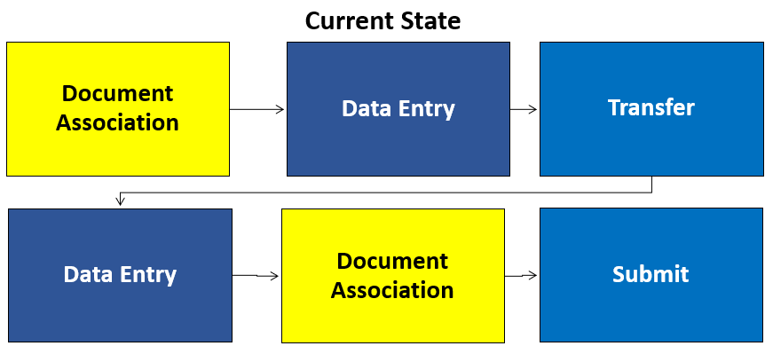

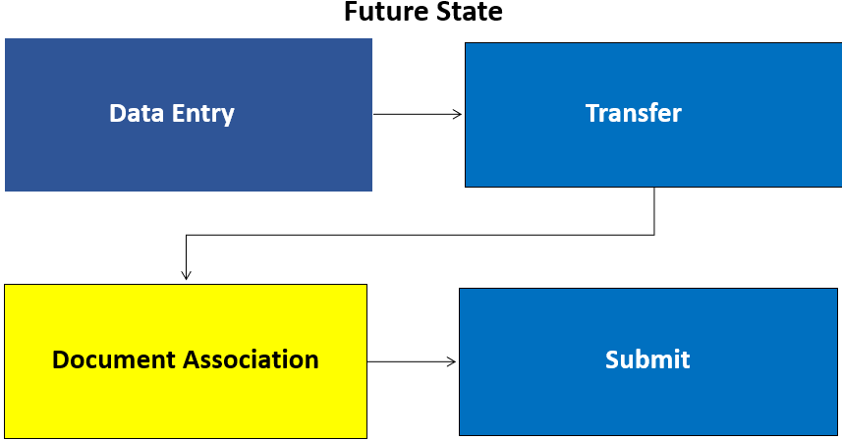

The future state (streamlined application flow) provides users with a seamless experience and a single point to associate documents.

TASs will have a two-year period beginning October 1, 2023, where both current state and streamlined application will be available. At the end of the 2-year period, only streamlined application will be available.

# Design flows

Examples of future state (streamlined application flow)

*Best viewed off VPN*

[JOA with uploaded resume](https://www.figma.com/proto/6AFrSy9axOo1Le1ODNeNVB/Streamlining---static-(07%2F08%2F2022)?node-id=0-6&scaling=scale-down-width&page-id=0%3A1&starting-point-node-id=0%3A3)

[JOA with builder resume](https://opm.invisionapp.com/console/share/RZ96S45DTQJ/982186255)

## What will remain the same in Streamline application flow:

**Applicant details**

The SIF sends applicant details from app guide to TASs.

**Required documents list**

The SIF sends required documents list and details from TAS to app guide. Applicants will see required documents for the JOA in the pre-application steps in USAJOBS.gov.

**Builder resume**

Occasionally, agencies require a builder resume only from the applicant.

**Identifying a JOA that requires builder resume**

The integration partner will identify if the JOA requires a builder resume.

**Making sure a builder resume is available**

When a JOA requires a builder resume, USAJOBS.gov will only send a builder resume to the TAS in the form of an XML. No other resumes are sent.

**Creating a builder resume**

Functionality is the same. App guide sends XML data to the TAS, and the integration partner creates the PDF for the agency. Integration partners and agencies should be aware that applicants may upload additional resumes during the document association portion and be prepared for the potential of more than just a Builder resume in the documents package.

**Uploading resumes and documents to profile**

Applicant can upload documents to their profile.

Any documents uploaded on the TAS side will not be uploaded automatically to the applicant’s profile on USAJOBS.

## What will change in Streamline application flow:

**User profile documents and certification statement**

|  |  |  |  |
| --- | --- | --- | --- |
| ID | Current state | Streamlined App Flow | Details |
| 1 | SIF sends only the list of resumes and documents selected by the user in the app guide to TASs. Minimum quantity is 1 resume. | SIF will make ALL resumes and documents in the app guide user profile available to the user in the TAS.  Minimum quantity 1 resume/0 documents and maximum quantity will be 5 resumes/10 documents. | Elimination of App guide being a point of selection of available documents. TAS will have ALL resumes and documents available that were uploaded to the user profile in app guide. |
| 2 | User selects resumes and documents to be associated to the JOA within app guide. | **Change:**  TAS will be the sole location to attach documents to application.  **Same as current state:**   1. When in the TAS, the applicant can select documents from the available list, the SIF retrieves the document from the user’s profile and adds it to the application. 2. User still has the ability to upload additional documents in the TAS. | Elimination of App guide as a means to associate a document to a JOA. TAS will be the only point of association of resumes and documents to JOA.  See below image for an example of the new functionality. |
| 3 | Includes the certification checkbox acknowledgement in the app guide. | The streamlined application is designed so that the checkbox acknowledgement is in the TAS at the application preview and before submitting.  Certification checkbox is moved to the end of the TAS application submission process. | The applicant must acknowledge the following certification statement before submitting the application:  *I certify, to the best of my knowledge and belief, all the information submitted by me with my application for employment is true, complete, and made in good faith, and that I have truthfully and accurately represented my work experience, knowledge, skills, abilities and education (degrees, accomplishments, etc.). I understand that the information provided may be investigated. I understand that misrepresenting my experience or education, or providing false or fraudulent information in or with my application may be grounds for not hiring me or for firing me after I begin work. I also understand that false or fraudulent statements may be punishable by fine or imprisonment (18 U.S.C. 1001).* |

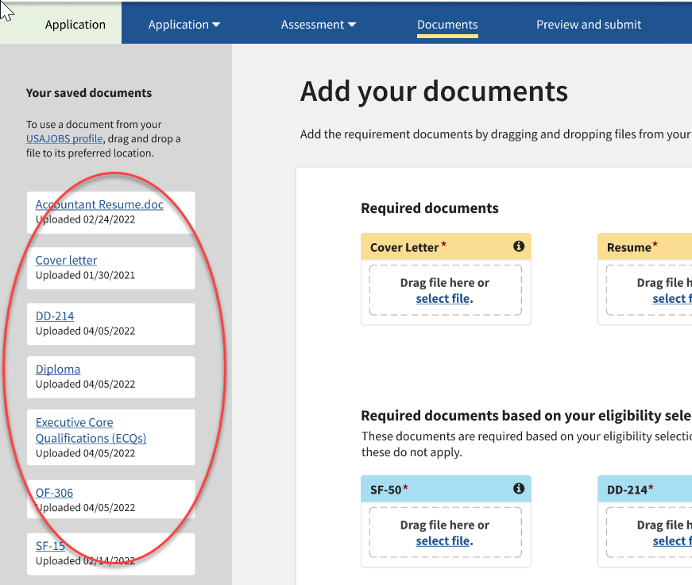

# Development and test

* Development occurs within each integration partner and TAS.
  + Email [vendor-help@usajobs.gov](mailto:vendor-help@usajobs.gov) with technical questions during development and test.
* The TASs can utilize the UAT environment to test: [www.uat.usajobs.gov](http://www.uat.usajobs.gov)
  + USAJOBS will provide sample test scenarios.
  + Reports defects or bugs immediately to [vendor-help@usajobs.gov](mailto:vendor-help@usajobs.gov)
  + A go live date can be provided only after integration partners submit an email confirmation that all test cases have passed, and the integration partner is ready to go live.

# How to implement

* Once the streamlined application is deployed, the integration partner can choose to roll out the new application process per individual JOA.
  + Using a SIF field value at the JOA level, the integration partner can select which application experience the applicant will use streamlined application or current app guide.
  + The SIF field value of either streamlined application or current app is selected at JOA creation and cannot be modified.
    - JOAs with an updated value will be rejected by the SIF.
  + Existing JOAs will remain live using the app guide originally selected.

# Timeline

The two-year implementation window begins October 1, 2023.

* JOAs posted after October 1, 2025, must use streamlined application.
  + JOA’s posted before October 1, 2025, will stay current app guide until their closing date.
  + Once all JOAs or public notices posted before October 1, 2025, are closed, USAJOBS will not offer the current app guide flow.
* As October 1, 2025, approaches, integration partners should use discretion if posting a JOA with an open period of longer than 9 months— especially if the integration partner can post the JOA when they’re using streamlined application.

USAJOBS support

* USAJOBS will provide resources for questions during the development, test and implementation phases for each TAS.
  + USAJOBS can also provide resources for meetings to address TAS- or system-specific questions.
* TASs will receive the implementation guide and technical documentation.
* USAJOBS will continue monthly UIS calls to bring up general issues or concerns.

## Business success checklist

Integration partners must complete these steps to successfully implement streamlined application.

New Required Development

* Pass values via **SIF field** on JOA for the selection of app guide; current flow is 0 and streamline flow is 1.
* Ensure TAS can **accept full list** of ALL documents and resumes from USAJOBS.
* Ensure user **can select** from the list of documents on the TAS side.
* Ensure **certification statement** is in the TAS prior to applicant submission.
* Ensure able **to run both** current app guide and streamlined application user experiences until all JOAs are on streamlined.

Test

* Test utilizing uat.usajobs.gov *(rollback plan, dual UI’s)* and report any bugs.
* Pass all scenarios in test plan.
* Provide confirmation email to [john.still@opm.gov](mailto:john.still@opm.gov) that integration partner is ready to go live. (Mandatory)

Deployment

* Use streamlined application on at least one JOA.
* Confirm success on streamlined rollout.
* Pass SIF field value for streamlined on all new JOA’s posted. Existing JOA’s must keep existing SIF value.

## Contact List

|  |  |  |
| --- | --- | --- |
| Issue | Contact | Contact Email |
| UAT questions and bug resolution support | Vendor Help (SLA 24 hours) | [vendor-help@usajobs.gov](mailto:vendor-help@usajobs.gov) |
| Technical suggestions | USAJOBS program management office | [recruiter-help@usajobs.gov](mailto:recruiter-help@usajobs.gov) |
| UAT confirmation and request for office hours/ TAS specific questions | Product Owner John Still | [john.still@opm.gov](mailto:john.still@opm.gov) |

# Appendix

Instructions on how to get access to GitHub- technical solution documents.

1. Go to github.com and create an account
2. Email [vendor-help@usajobs.gov](mailto:vendor-help@usajobs.gov) to request access to the USAJOBS GitHub repro. Providing the email address of the GitHub account you created.

Technical documents are available at <https://github.com/USAJOBS/schemas>

If there are technical suggestions, please email the USAJOBS program management office at [recruiter-help@usajobs.gov](mailto:recruiter-help@usajobs.gov). If assistance is required or system challenges with the SIF environment need to be reported, please email [vendor-help@usajobs.gov](mailto:vendor-help@usajobs.gov)

## Rollback scenarios

**How do we decrease risks?**

Since each TAS can implement this by individual JOA, the volume and speed of rollout is within the control of each TAS.

For example: A TAS can set one or two JOAs to use streamlined application and tracked before the TAS determines that all JOAs should use the streamlined application flow.

**What is the rollback plan?**

All new features have risks. User acceptance testing and a slow rollout help decrease the chance of rolling back the feature.

If an unforeseen issue with USAJOBS code or TAS code occurs after streamlined application is in production, the following rollback steps are outlined below.

**USAJOBS​ rollback steps:**

The USAJOBS scrum team will work with data team to capture the number of applicants for JOAs using streamlined application: ​

**Group A:** Users that started the application process but hadn’t moved on to a TAS yet.​

**Group B:** Users that were in the application process in the TAS, but not yet submitted. ​

**Group C:** Users that submitted their application.​

**Integration Partner rollback steps:**

1. Make sure all future JOAs do not indicate streamlined application​ as the app guide in the SIF.
2. Cancel all live JOAs that were set to streamlined application.​
3. Repost the position with the application experience set as current app guide.​
4. Invite users from groups A, ‘B’, and ‘C’ to reapply to the reposted positions.​